Dear Parent(s),
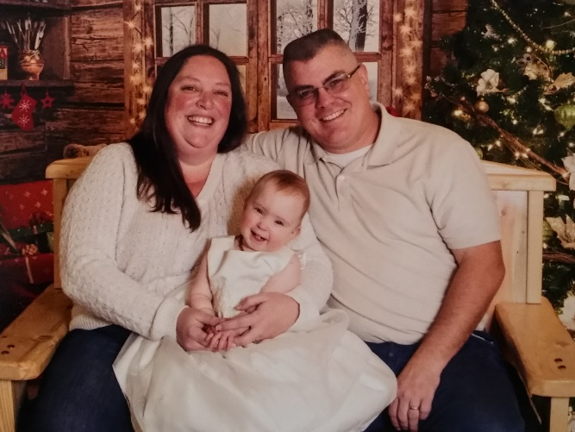
We can only imagine the rollercoaster of emotions that you must be going through as you consider making a very difficult and important decision and pray that, whatever the result, you feel confident that you made the right one. Know that you are loved and will always be important to your child. Our hope is that you put us in the position to help you weather the next few chapters in your life and that together we can write your child a happy growing up story.
We are Matt and Carrie, and we have been praying for you for a really long time. Just as you most likely did not expect to be where you are in life right now, our path to this point has been a long and bumpy one. We have been married for 24 years and recently moved to Great Falls after Matt’s retirement from the Marine Corps in 2013. Matt currently works as a contractor with the Montana Air National Guard, and Carrie keeps herself busy taking care of our home and daughter, Sarah, along with numerous craft projects. We both enjoy camping, kayaking, floating the rivers, and other outdoor activities in the summertime. Matt hunts deer and elk to fill our freezer in the fall, and we enjoy watching movies, putting puzzles together, and playing family games in the winter time. We are active in our church and love spending time with friends.
Matt grew up in a military family and moved a lot as he was growing up, but mostly along the east coast. His mother was a stay at home mom and his dad was in the Navy. He was active in Boy Scouts and sports growing up, playing soccer, volleyball, football, SCUBA diving and spending time at the beach. After high school, Matt went to college for a year and a half, but found it wasn’t for him so he came home and, after a couple of jobs here and there, joined the Marine Corps. His 20 year career in the Marines took him all over the world, which allowed him to experience many different cultures.
Carrie grew up in Texas, Mississippi, and Tennessee in a much larger family. She had one biological sister, and 2 sisters and a brother adopted from foster care. Carrie’s father passed away shortly after she was born, so her mother had to work very hard to raise all those children by herself. Carrie and her sister sang at the church their family attended and she played volleyball in high school.
We met in Memphis, Tennessee shortly after Carrie graduated High School while Matt was there for training and got married in Las Vegas after dating for 6 months. During our 24 years together, we have lived in Texas, North Carolina, Japan, and Montana. Shortly after we got married, we found out that we were unable to have children naturally so we tried all kinds of fertility treatments and numerous invitro-fertilizations but were not successful.
In 2010 we decided that adoption was God’s plan for us and, since Carrie had siblings adopted through foster care, we decided to become a licensed foster family to try and help children who really needed it. Saying goodbye over and over again to children we loved proved to be harder than we thought though, so we contacted CSSM to help us find the perfect addition to our family. We were blessed with Sarah Grace in September of 2017 and have enjoyed every moment since she and her birth family joined our lives. We believe that children grow up happier with siblings for playmates, so we are looking to add a brother or sister to share our adventures with. We are grateful that you have taken the time to read a little about us and are excited to see what God has in store for all of us. Know that we are praying for you and your child, whoever you choose and whatever decision you come to.
God Bless You Always,
Matt and Carrie

