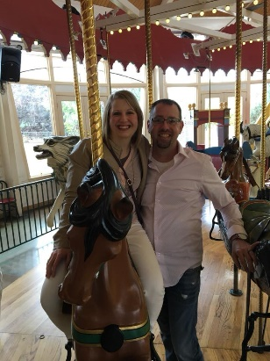 Dear expectant mom,
We would like to thank you from the bottom of our heart for taking the time to get to know our family and considering us for the tremendous role of parenting your child. Our names are Steve and Richelle!
Steve and I met at School at Concordia University in Seward Nebraska. We became good friends right away and started hanging out quite a bite. After about six months we grew very fond of each other and decided to enter into a dating relationship. Steve and I dated for six more months and then realized that we wanted to spend the rest of our lives together. We got married a year later in my home town of Billings Montana. We both really enjoy Christmas so we decided to get married December 19, 2009. We have been married for almost eleven years; we have had some challenges along the way- infertility being one of our biggest challenges. Today we are stronger because of these challenges and are ready for our next adventure of parenthood through adoption.
As a couple we like to spend time with our friends and family, and be outside barbequing a great meal. We enjoy just going to coffee together and talking about life and goals that we have for our life together. One of our favorite things to do is be out on the water in a boat or in a kayak. We both also like to travel and see different museums and land marks. We both also like to watch Nebraska Husker games with friends and family. One of our favorite summer things we like to do is go to Billings Mustang games and watch baseball.
HI, I am Steve. I was born in Bloomington, IL. All of my family lives mostly in Illinois. I have 3 siblings which are all older than me. I have a sister Cheryl, Kathy and a brother Bobby. My two sisters are married with spouses and have 5 nieces from them. My brother and his wife and three kids live in Texas and we see them a few times a year. I have a Bachelor’s of Arts degree from Concordia University in Seward NE. I have used my degree to work with youth in ministry. I am currently working in sales where I can use my degree in helping people solve problems and help them connect with certain products. I love being around children and youth which is why I went into youth ministry. I look forward to one day helping my child walk in faith as I have helped many young kids walk in faith.
Hello, I am Richelle. I was born and raised in Montana. My immediate family also lives her in Montana. I have two brothers, two nieces, and one nephew who live about five to ten minutes away. We are all very close and get together quite frequently. I have and education degree and currently working on my nursing degree at MSU. I really enjoy working with mom’s and children. I love being able to greet patients and getting to know them and feel that I am part of helping them get better or feel more comfortable while at their visit. I love to read for knowledge and for fun. I look forward to the day when I can do bath time and read books to our child. I am completely ready to step into my new role as mom.
Over the last almost eleven years of our marriage we have strongly felt God calling us to adopt. We truly believe that there are lots of children and moms that need love that maybe they have never been show in their life. We do understand as well that it is very important to have an open relationship with our child’s birth mother.
We pray that our child will feel loved and supported by our family, and yours as well as we continue this adventure adoption and bringing two families together. We will share our child’s birth story daily. We know that through this it will help our child feel part of both families and understand where they come from.
We cannot even come close to understanding what you have been through or what is ahead of you. We are so very blessed to enter parenthood through adoption. Deciding to do an adoption plan has to be the hardest, selfless, and bravest decision you have ever had to make. We want to know that we are praying for you daily and that you are loved. We want you to know that you are not alone and that there are people out there who do care about you.
We want to thank you again for getting to know us and considering us to parent your child. We are so looking forward to meeting you and getting to know you and your family.

God’s Blessings,
Steve and Richelle

