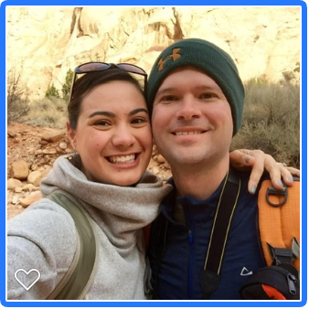
Dear Parent(s),
We are Jon and Kristina and we are so grateful that you are taking the time to read our letter. Although we haven’t met, we hope that this letter will help you get to know us a little bit.
We met over ten years ago in Omaha Nebraska while Kristina was going to college. It was the love of the outdoors that brought us together and our first date was on a hike through the forest. In 2011 we got married near Seeley Lake Montana and it was the happiest day of our lives. We were finally able to bring both of our families together to celebrate and have a great time together! After a few years, we decided we should start trying for our own family. Unfortunately, this never happened. We tried medical treatments for a time, but had no success. In the end we decided that we should look into adoption as a way to grow our family. It took us a long time to get here, but we can’t help feeling that we are finally on the path that we were meant to take.
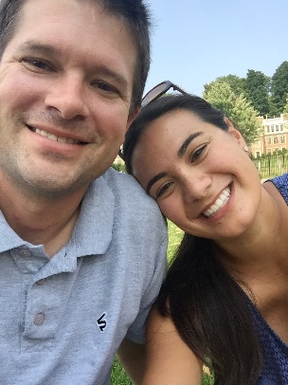
Kristina- I grew up in rural Montana. I had a fun childhood living in the country with my mom, dad, my little sister and our several pets. As a kid, I loved reading and playing volleyball but my favorite hobbies were drawing, and painting. When I graduated from high school, I left Montana and went to college in Nebraska. I studied Biology and Nursing and I have been a nurse since 2011.
Jon- I grew up on a farm in Minnesota. I have an older brother and a younger sister who now has three little kids. When I wasn’t working on the farm, I participated in 4H, played basketball and ran in track. I have always had a love for the outdoors and so I went to school to study biology and environmental science.
In 2014, we moved to Montana from Omaha. It was a big adjustment at first, but the Montana outdoor lifestyle suits us well. The year after we moved, we bought a house close to hiking trails so that we can enjoy the outdoors every day. Each morning, Jon gets up early to take our dog, Bailey, on a run up the mountain so she can explore and get her exercise.
In addition to hiking and outdoor activities, we also love to travel. We are very lucky to have been able to travel all over the country and all over the world. But as exciting as it is to see new and different places, our favorite part of our adventures is coming home to spend time with our friends and family.
We are both very close with our families and they have always been very caring and supportive. Since Kristina’s family lives in Montana, we get to see them on a regular basis. Most of Jon’s family lives in Minnesota and New Hampshire, but each year we get together for a big family vacation during the summer months. We love these vacations since we get to spend quality time with our niece and two nephews.
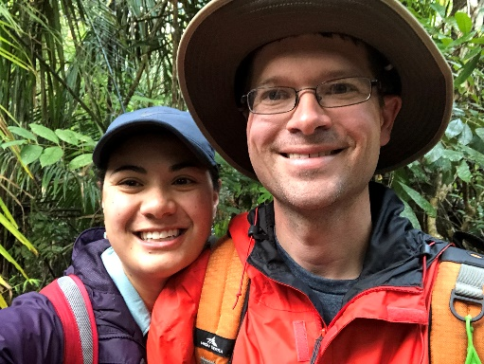
We hope that in the future we can add a new member to our family. We are very kind and caring people and we can’t wait to bring a little one into our lives. We know that we can provide a safe, loving and supportive home, full of laughter and fun. A home that will be welcoming, not just to our future child, but to the birth family as well! We know you have a big decision ahead of you, and we want to thank you again for taking the time to get to know us.

From the bottom of our hearts, we wish you all the best,
Jon and Kristina

