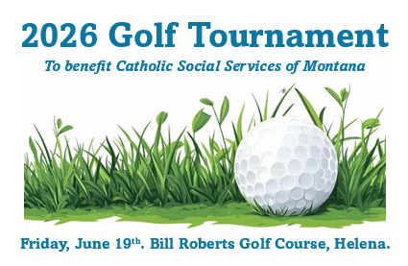
Results and Award Winners

Place | Team |  | Shots | Award
T-1, 1st | Johnson/McCarvel |  | 53 | Trophy and $50 gift card for each teammate
T-1, 2nd | Placer Subaru |  | 53 | New rangefinders for each teammate
T-1, 3rd | Great Clips |  | 53 | $25 gift card for each teammate
4 | Aaron’s Plumbing and Heating |  | 54
5 | D&D RV Center |  | 55
6 | Shanks-a-Lot |  | 56
7 | KoC #844 #1 |  | 57
8 | Grip It and Rip It |  | 57
9 | Last Chance Casino |  | 58
10 | Team M.E.A.T. |  | 59
11 | The Dalton Gang |  | 61
T-12, 1st | KoC #844 #2 |  | 62 | Free car washes to Woody’s Car Wash
T-12, 2nd | Gruber Masonry |  | 62 | Mugs, tees, towel for each teammate
T-12, 3rd | That’s a Gimme |  | 62
15 | Michael O’s Team |  | 63
T-16 | Bernie M & Co |  | 64
T-16 | Ss Cyril and Methodius A |  | 64
T-16 | Ss Cyril and Methodius B |  | 64
T-19 | Cathedral High |  | 65
T-19 | Fore Men |  | 65
T-21 | Pagan Babies |  | 68
T-21 | Sleeping Giant Appraisals |  | 68
T-21, 3rd | Montana City Grill |  | 68 | Mugs, tees, towel for each teammate
24 | Iron Sharpens Irons |  | 70 | Golf ball retriever for each teammate
25 | Catholic Social Services of MT |  | 72 | Trophy for each teammate
Event |  | Winner(s) |  | Award
Long Drive |  | Jordan Wanner  Julia Barthelemy |  | Bottle of rum for each from MT Glass Liquor
Marshmallow Long Drive |  | 1st- Jordan Wanner  2nd- Spencer Berger |  | Large s’mores gift basket from D&D RV Center  Small s’mores gift basket from D&D RV Center
Shortest Drive |  | 1st- Andy Galen  2nd- Steve Nash |  | Montana Lottery gift bag  Woody’s Car Wash free wash
Long Putt |  | Michael Ollis  Linda Brown |  | Free round of golf and cart for two for each to Bill Roberts or Green Meadow CC
Mulligan Drawing |  | Bernie Adams |  | $25 Vanilla Bean gift card
Closest to the Pin |  | 1st- Luke Eckmann  Random- Doug Martin |  | Three free rounds of golf and cart to courses in Billings Framed photo from Ghost Art Gallery
“I’d Rather be at the beach” |  | Chris Rehor |  | Caesar basket from Gold Island Liquor Store
Cornhole Challenge |  | Spencer Berger |  | Moen stainless steel faucet
Lawn Darts Drawing |  | Ray Pancich |  | Golf club bag
Yardzee Drawing |  | Sam Clark |  | Handmade wooden dish set
Baby Boutique Drawing |  | Jeff Cowee |  | $50 Creative Stitches gift card

